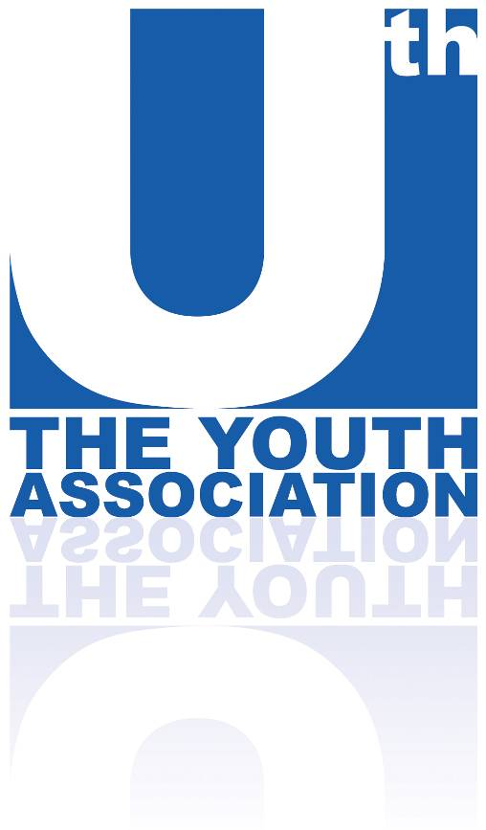
Youth Work Practice
Level 2 Award
Level 3 Certificate



About the course

Youth Work
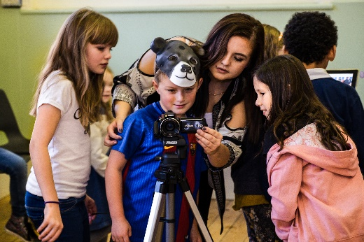
Helping young people improve their lives is as important today as it has been ever before. Youth workers help young people stay on the right path in life, help them reach their potential and help people become whoever they want to be in life. Youth workers recognize that human beings are social creatures who can learn, develop and grow through collaboration with those around them. To help young people develop, they facilitate social situations, in which young people work within their peer groups, taking part in challenging and developmental activities.

Course content

On the course, you’ll study a variety of areas relating to young people. You’ll learn a bit about how young people behave and how groups and communities interact. The course covers the essential elements of modern youth work theory and practice.

The Youth Work course effectively blends the academic and the practical. As well as written/portfolio work and classroom learning, it provides learners with a hands-on introduction to working with young people. The course ensures you’ve had many hours of practical experience in a wide range of settings, such as youth clubs, sports projects, creative/arts groups and within community settings.

Units | Level 2 Award | Level 3 Certificate
Engaging and communicating with young people
Theory of Youth Work
Young people’s development
Safeguarding
Group Work within a Youth Work Setting
Challenging Behaviour in Youth Work Settings
Anti-Discriminatory Practice in Youth Work
Work-based Practice in Youth Work
Reflective Practice in a Youth Work Setting

Careers and further study

Careers
The primary career, directly linked to this course, is youth work. Youth workers usually work in council-run, or third-sector, youth services. They help young people develop skills, attitudes and social/emotional resilience, by facilitating social/group situations where young people take part in challenging and developmental activities.

However, working with children, young people and communities spans many industry sectors. This course could therefore lead a student to consider a wide range of careers, including working within:

- Youth services
- Schools and colleges
- Youth offending teams
- Housing associations
- Alcohol/drug misuse agencies
- Employment/careers agencies
- Community centres
- Sexual health clinics
- …and many more


If, upon finishing their studies, a student wants to try something different career-wise, the Youth Work and Community Development certificates also enables them to deviate into other related area, such as:
- Teaching
- Social work
- Social care
- Mentoring
- Community development
- Community education
- Family support
- Probation
- Teaching assistant

Further study
There are several universities in our region that may be of interest for students looking for further study. Leeds Beckett University, University of Huddersfield and University of Hull all run a BA Youth and Community Work degree. Outside of Yorkshire, many other universities run the same course and other, related courses.

The following link to the National Youth Agency website provides a full list of degree and postgraduate youth work training available in the Yorkshire & the Humber region
www.nya.org.uk/careers-youth-work

